Project Design Phase SolutionArchitecture

Date | 19February2026
TeamID | LTVIP2026TMIDS66458
ProjectName | GeminiHistoricalArtifactDescription
MaximumMarks | 4 Marks

SolutionArchitecture:
Solutionarchitectureisacomplexprocesswithmanysub-processesthatbridgesthegapbetween business problems and technology solutions. Its goals are to:

- Findthebesttechsolutiontosolveexistingbusiness problems.
- Describe the structure, characteristics, behavior, and other aspects of the software to project stakeholders.
- Definefeatures,developmentphases,andsolutionrequirements.
- Providespecificationsaccordingtowhichthesolutionisdefined,managed,anddelivered.

Example-SolutionArchitectureDiagram:

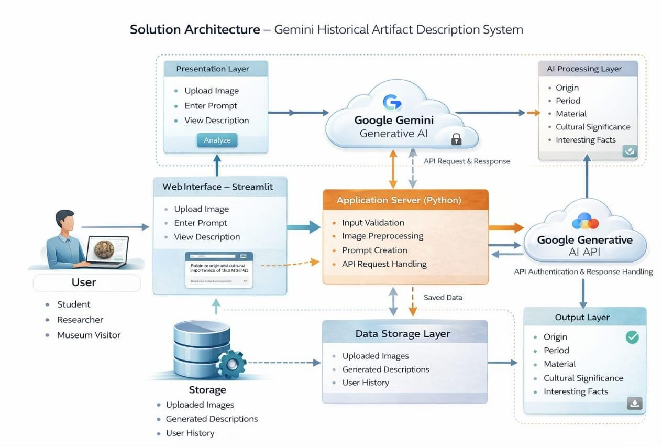

Step-by-StepWorking:

Step-1:Useropensthesystem
- The user (student / museum visitor / researcher) opens the web or mobile application and logs in.
- Thesystemshowsacamera/uploadoption.

Step-2:CaptureorUploadImage
Theusertakesaphotoofahistoricalartifact(statue,coin,templecarving,weapon,inscription)or uploads an existing image from the gallery.

Step-3:ImagesenttoBackendServer
- Theapplicationsendstheimagetothebackendserverthroughtheinternet(APIrequest).
- Theserverreceivestheimageandpreparesitfor processing.

Step-4:AIImageAnalysis(Gemini/VisionModel)
- TheAImodel analyzesthepicture:
  - detectsobjecttype
  - identifiesmaterial(stone,bronze,gold,etc.)
  - recognizeshistoricalperiod
  - findssymbolsortext
- Thisisthemainbrainofyourproject.

Step-5:HistoricalKnowledgeRetrieval(Database)
Afteridentification,theserverchecksthehistoricaldatabase:
- monumentdetails
- dynasty/kingdom
- usageand purpose
- locationandcultural importance

Step-6:GenerateDescription(GenerativeAI)
GeminiAIgeneratesahuman-readableexplanationlikeamuseumguide:
- nameofartifact
- origin
- age
- storybehindit
- importance

Step-7:OptionalTranslation&VoiceOutput
  - Thesystemcan:
    - translateintoregionallanguages(Tamil/Hindi/English)
    - converttexttospeech(audioguide) So the user can hear like a tour guide.

Step-8:Resultdisplayedtouser
Finally,theapplicationshows:
- artifactimage
- detaileddescription

- historicalfacts
- audio narration
Theusernowunderstandstheartifactinstantly–'–‘l_Hµ_µ.

